,
PANASONIC
&
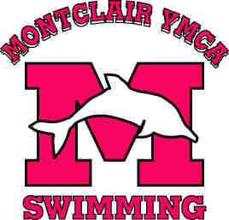Montclair YMCA Dolphins Present:

A Day with Mark Spitz
Considered the Greatest Olympic athlete of all-time, the name Mark Spitz is synonymous with excellence. Mark Spitz is known the world over as one of the most recognized faces in sports. In 2000, Mark was voted Athlete of the Century in water sports and one of the six greatest Olympians ever by Sports Illustrated. Recently, the International Olympic Committee selected Mark as one of its five athletes of the Century.
Mark Spitz has won more Olympic medals than any U.S. athlete (11 medals). He broke seven world records in winning 7 Olympic Gold Medals at the 1972 Munich Games. He was the 1971 Sullivan Award winner as the best amateur athlete in the United States.
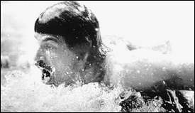
When: Friday, July 16th from 3 to 5 pm – Arrive at 2:30 Sharp
Where: The Montclair YMCA on Park Avenue
Who’s Invited: All DOLPHIN SWIM TEAM MEMBERS and PARENTS ONLY are invited
What: An in house fun competition and stroke clinic with Mark Spitz – Swimmers can choose between free, fly or both. Please see back page to sign up!
This will be an exciting opportunity to meet the man who is considered to be the world’s greatest male swimmer of all time. Mark will be conducting a motivational session at 3 PM followed by an in house meet at 4 PM where the event winners will be afforded the opportunity to work in a small group with Mark.
The Montclair YMCA is looking forward to be able to provide our athletes with an informative and fun session. We hope to see you there!

CIRCLE ONE OF THE FOLLOWING FREESTYLE BUTTERFLY BOTH EVENTs
DEADLINE TO REGISTER is Friday, July 9th. Prizes will go to the first 30 swimmers registered. Hand deliver to BG, Jon or to BG’s family file in order to register.

